Plant Vogtle Units 3 & 4

Third Semi-Annual
Construction Monitoring Report

August 2010

Docket No. 29849

EXECUTIVE SUMMARY

This is the third semi-annual Vogtle Construction Monitoring report (“Third VCM Report”) submitted by Georgia Power Company (“Georgia Power” or the “Company”) to the Georgia Public Service Commission (the “Commission”) pursuant to the stipulation (the “Stipulation”) adopted in the Commission’s order in Docket No. 27800 (the “Certification Order”).

In this Third VCM Report, the Company requests that the Commission verify and approve the expenditures that were invested in the construction of Plant Vogtle Units 3 and 4 (the “Project”) during the reporting period of January 1, 2010 through June 30, 2010 (the “Reporting Period”). This Third VCM Report provides the basis upon which the Commission may verify and approve such expenditures as made pursuant to the certificate in accordance with O.C.G.A. § 46-3A-7(b). In addition, the Company’s semi-annual reports generally provide the basis by which the Commission may approve, disapprove, or modify any proposed revisions in the Project schedule and budget; however, the Company is not requesting any changes to the overall Project schedule or budget for this Reporting Period.

This executive summary provides an overview of the information contained in this Third VCM Report. Construction of units 3 and 4 at Plant Vogtle (the “Units”) is on schedule and on budget, demonstrating that cost pressures are being actively and prudently managed. The Company wishes to highlight several key developments and issues to put the progress of the Project in context.

As more fully described in response to Item 10 herein, there are issues that have the potential to ultimately delay the issuance of the AP1000 Design Certification Amendment (“DCA”), the Westinghouse Design Control Document (“DCD”), and, thus, the combined construction and operating license (“COL”). However, in a Nuclear Regulatory Commission (“NRC”) letter to Westinghouse Electric Company LLC (“Westinghouse”) dated June 21, 2010, the NRC communicated the schedule for the DCA for the AP1000 Design Certification, establishing September 2011 as the date for the Final Rulemaking. The COL cannot be issued until after the Final Rulemaking. The exact timeline for COL issuance is uncertain because this process is being implemented for the first time and the schedules for the hearing on the COL and the final determination and order by NRC relative to the COL will not be established by the NRC until review of the DCD and preparation of the documents supporting the Final Rulemaking progress further. The Company’s current estimate is that the COL would be issued six to eight weeks following the Final Rulemaking, subject to the extent to which the NRC’s commitment of resources to the DCD review permits concurrent processing of the COL. The Company’s expectation of Westinghouse and Stone & Webster, Inc. (together with Westinghouse, the “Consortium”) regarding the schedule is to reduce construction time in order to make up for DCD delays to meet the commercial operation date (“COD”) for Unit 3, which remains April 1, 2016 and Unit 4, which remains April 1, 2017.

During the Reporting Period, the Consortium commenced backfill activities on the Units. As these activities commenced, the Consortium discovered that adequate amounts of suitable backfill were not available in the locations identified in the Early Site Permit (“ESP”). As a result, the Company submitted three requests to the NRC to amend the ESP. These ESP amendments requested the Company be allowed to retrieve and use backfill soil from additional areas on the Project site and to allow for the use of engineered backfill on the side slopes of the Units’ excavations. The NRC quickly approved the first two ESP amendments within the Reporting Period, and the third ESP amendment was approved shortly thereafter, on July 13, 2010. Current projections indicate sufficient backfill quantities are on-site, which would eliminate the need for any off-site material.

A significant accomplishment with regard to the ESP during this Reporting Period was the withdrawal of the appeal of the dismissal of the Joint Intervenors’ contention. In the previous reporting period, the Joint Intervenors had appealed the dismissal of certain ESP contentions to the NRC, and also appealed to the D. C. Circuit. In January 2010, the NRC dismissed the appeal and in March 2010, the Joint Intervenors withdrew their appeal from the D. C. Circuit. Thus all challenges are now closed on the receipt of the ESP. As of June 30, 2010, the COL proceeding was uncontested with the dismissal of the Low Level Radwaste contention by the Atomic Safety and Licensing Board (“ASLB”).

Also during the Reporting Period, and as reflected in the permitting table in Item 11 herein, the Company has now received both the Air Quality Construction Permit as well as the Title V Operating Permit. Furthermore, during the Reporting Period, Shaw Modular Solutions (“SMS”) began structural module fabrication. As described in Item 12, SMS is in the process of amending its procedures to ensure compliance with its quality assurance standards. The Company’s Vendor Surveillance and Quality Assurance Organizations continue to work with Shaw and SMS to resolve any deficiencies in the current procedures.

The Commission Staff and the Construction Monitor have been kept abreast of the progress of construction and the issues discussed above through their review of the Level 1 schedule and the Vogtle 3 and 4 Project Metrics Packages, which show progress to date against the milestones. At this time, even considering potential new and emerging issues, the Project remains on schedule to meet the expected COD for each Unit.

While the Project continues to track under the $6.113 billion certified amount (the “Certified Amount”), as with any project of this magnitude, it is now apparent that the cost of several individual items will be greater than budgeted while the cost of others will be less than budgeted; however, the overall net change in the projected cost of the Project is favorable.

The recently approved Amendment No. 3 to the Engineering, Procurement and Construction (“EPC”) Agreement replaces certain index-based adjustments to the purchase price with fixed escalation amounts. This Amendment, approved by the Commission on August 17, 2010, shifts the significant risk of higher than anticipated escalation from customers to the Consortium. The Total Current Forecast reflects the adoption of Amendment No. 3.

On February 16, 2010, the Department of Energy (“DOE”) offered the Company a conditional commitment for a federal loan guarantee (“Loan Guarantee”) that would apply to future Company borrowings related to the Units. The Loan Guarantee would be full recourse to the Company and would be secured by a first priority lien on the Company’s ownership interest in the Units. The Loan Guarantee would not exceed 70 percent of eligible Project costs, or approximately $3.4 billion, and is expected to be funded by the Federal Financing Bank. As a result of the Loan Guarantee, Georgia Power and its customers are expected to save approximately $15 million to $20 million in interest costs annually, at the corporate level, over the expected life of the bonds.

On June 18, 2010, Georgia Power accepted DOE’s conditional commitment. Final approval and issuance of the Loan Guarantee is subject to receipt of the COL for the Units from the NRC, negotiation of final agreements, completion of due diligence by the DOE, and receipt of any necessary regulatory approvals or conditions as defined in the definitive agreements. There can be no assurance that the DOE will issue a Loan Guarantee to the Company. It is also important to note that while the expected benefits of the Loan Guarantee have been reflected in the Total Current Forecast, the Total Current Forecast does not yet reflect any negative cost impacts that might result from the need to comply with federal regulations pertaining to entities that accept a Loan Guarantee.

In conclusion, the Company is currently managing cost pressures and risk, and as a result, the Total Current Forecast is within the $6.113 billion Certified Amount. While there remains a favorable variance between the Certified Amount and the Total Current Forecast, the Company acknowledges that this variance may change over time as the Project continues, and therefore the Company does not request an adjustment to the Certified Amount at this time.
As agreed in the Stipulation that was incorporated into the Certification Order, the Company responds to the 15 specified items, in the order in which they appear in Section 2(d)(1-15) of the Stipulation as follows:

- The reasons for any additional change in the estimated costs of the units since the process began.

The Company reports against a total certified cost of $6.113 billion. The cost reports are provided in Tables 1.1 and 1.1a below.

Table 1.1
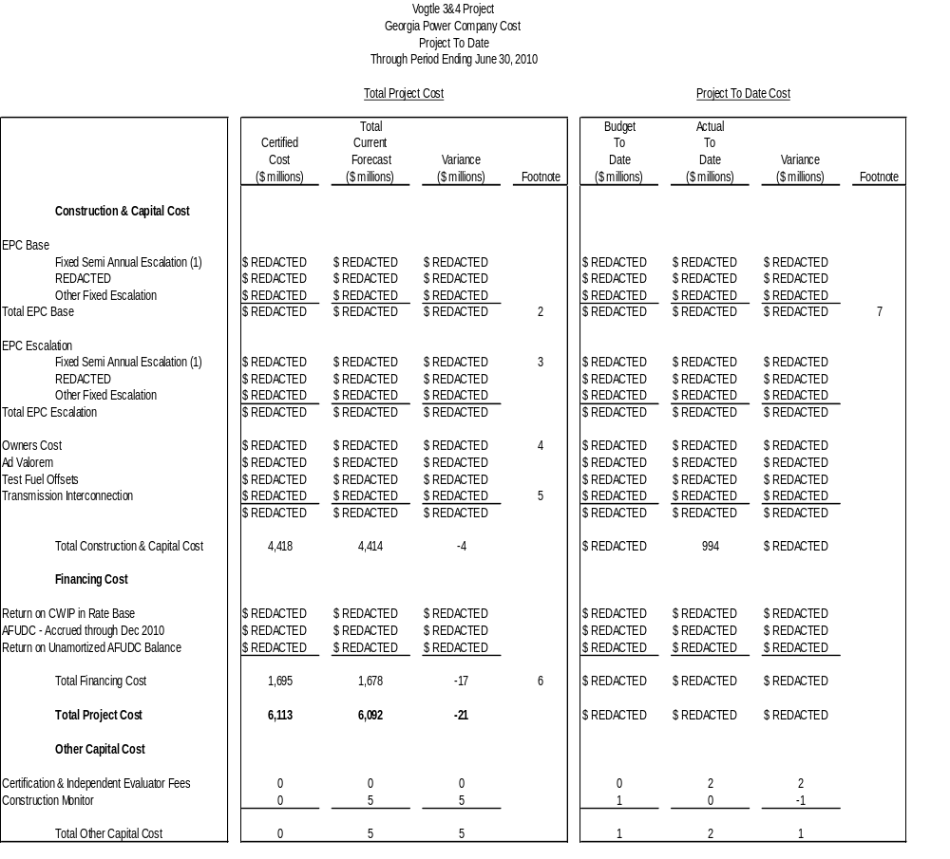
Footnotes
- As a result of Amendment No. 3 to the EPC Agreement, the REDACTED REDACTED has been replaced with Fixed Semi Annual Escalation
- EPC Base increased $REDACTED as a result of simulator budget transfer from Owners Cost.
- The certified cost reflects the REDACTED escalation rate estimated at REDACTED; current forecast reflects the Fixed Semi Annual Escalation provisions of Amendment No. 3 to the EPC Agreement.
- Owners Cost reflects an increase of $REDACTED partially off-set by a decrease of $REDACTED for simulator budget transferred to EPC Base and a decrease of $REDACTED for transmission items transferred to Transmission Interconnection. Changes in Owners Cost are further described in Item 9.
- Transmission Interconnection reflects an increase of $REDACTED which is the current estimate for cost issues associated with additional transmission work that was described in the Second VCM Report. These items were previously categorized in Owners Cost.
- Current forecast variance due mostly to timing of capital spending; includes expected benefits of the DOE Loan Guarantee partially offset by increases in long term interest rate forecasts.
- Variance due to timing of completed milestones.

Note: Details may not add to totals due to rounding.
Table 1.1a (Trend) 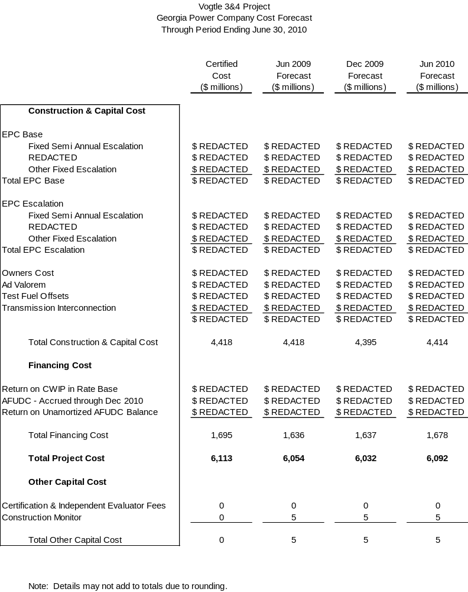
- A description of any cooperative actions between other builders of nuclear units in the southeast to address labor, crafts, engineering and management requirements.

Southern Nuclear Operating Company (“SNC”) cooperates with other builders of nuclear units to address engineering and management requirements via industry related groups. These groups provide forums for builders of a given technology type to consider issues common to the participants, including development of training, procedures and programs. The groups operate under strict antitrust rules and do not collaborate in any way to influence the labor markets.

As a member of APOG, SNC has asked the other APOG members (Progress Energy Carolinas, Duke Energy Carolinas, Florida Power & Light and South Carolina Electric and Gas Company (“SCE&G”)) to support the following activities either through financial means or with participation.

- Development of a knowledge and abilities (“K&A”) catalog that provides the basis for the NRC licensed operator training and examinations throughout the life of the plant. This document will be submitted on behalf of the industry to the NRC later this year.
- Review of Westinghouse procedures and development of a standard set of operation and maintenance procedures that will be proposed to all AP1000 utilities.
- Review of engineering and design issues with Westinghouse to resolve common problems for the benefit of all AP1000 owners.
- Review of the Westinghouse and Shaw lessons learned program to ensure lessons learned from China and other AP1000 utilities are reviewed and, if needed, incorporated into the design.
- In addition, a full time APOG manager was hired to develop the programs necessary for testing, startup and eventual operation of the AP1000. These programs range from engineering programs to maintenance, chemistry, health physics, operations, Occupational Safety and Health Administration compliance, et. al., as related to the AP1000.

SNC, in cooperation with SCE&G, has contracted with Westinghouse for initial training program development, instruction, and certification of utility licensed operator instructors. The first group of 24 instructors (12 each from SCE&G and SNC) completed nine weeks of initial training on July 2, 2010. Additional training will take place later in 2010 and throughout 2011. SNC and SCE&G are in final negotiations to procure services for a Probabilistic Risk Assessment (“PRA”) model. The PRA is needed for several risk informed programs that will be developed under a cost-sharing approach with other participating utilities, which reduces the cost the Company would have incurred if it were required to procure such services independently.

SNC is also a member of NuStart Energy, a consortium of utilities and two reactor vendors whose purpose is to demonstrate the COL process and complete design finalization activities for the two reactor technologies, the Westinghouse AP1000 and the General Electric ESBWR. This Project has transitioned to serve as the AP1000 Reference Combined Operating License Application and is a leader in both the licensing and engineering areas for the AP1000 utilities. The engineering team provides input to Westinghouse design finalization efforts and promotes standardization of site-specific design, where practical.

In addition to the items listed above, SNC also participates in leadership roles for various Nuclear Energy Institute (“NEI”) sponsored groups, specifically, the Designed Centered Working Group (“DCWG”), the New Plant Working Group (“NPWG”) and the New Plant Oversight Committee (“NPOC”). The DCWG formed by NEI at the request of the NRC is made up of the AP1000 utilities with the purpose of standardizing licensing activities associated with the DCD, the COL and construction of the AP1000. The NPWG, managed by NEI, is a policy-making group that establishes guidance for addressing the NRC, legislative and public affair issues for new reactors (e.g. AP1000, ESBWR) and modular reactors. The direction for the NPWG is established by the NPOC, which is made up of nuclear industry executives.

- An explanation of how the indices used in the EPC contract are tracking.

On February 22, 2010, the Consortium and Georgia Power, acting for itself and as agent for Oglethorpe Power Corporation, Municipal Electric Authority of Georgia and the City of Dalton (the “Owners”) entered into Amendment No. 3 to the EPC Agreement. Amendment No. 3, which was approved by the Commission on August 17, 2010, replaces certain index-based adjustments to the purchase price with fixed escalation amounts.

With Amendment No. 3 in place, the only remaining index is the REDACTED, which is currently tracking REDACTED original estimates, as shown in Table 3.1.

Table 3.1
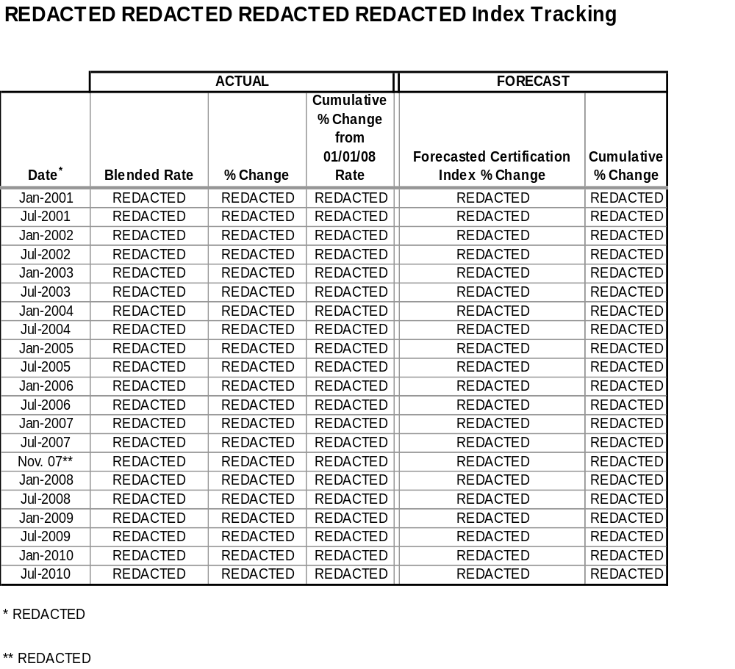

- Any updated estimate of on site spent fuel storage costs, including the costs for dry storage of spent fuel for an extended period of time after shutdown, and any updated calculation of spent fuel storage costs assuming Yucca Mountain is never available.

As previously reported, the Company provided a sensitivity analysis for spent fuel storage costs to the Commission Staff (“Staff”) and the Independent Evaluator in October 2008 that estimated the cost of on-site storage through 2088, which is ten years beyond the anticipated shutdown of Unit 4. There is no change at this time to the estimate provided in October 2008.

In addition, SNC executed a contract with the DOE in November 2008 that requires the DOE to complete removal of spent fuel from the Units within ten years from the date of the shutdown of Unit 4.

In January 2010, after the current Administration’s decision to withdraw from the Yucca Mountain initiative, the President asked the U.S. Secretary of Energy to establish the “Blue Ribbon Commission on America’s Nuclear Future.” The mandate to the 15-member Blue Ribbon Commission is to address the issue of long-term storage and disposal options for spent nuclear fuel. Specifically, the Blue Ribbon Commission is charged with developing policy recommendations and suggesting legislative changes to address alternative storage options, spent fuel recycling and disposal options. The Blue Ribbon Commission is to deliver an interim report within 18 months and a final report within 24 months.

- The status of the Company’s loan guarantee application at the Department of Energy and to the extent that application is granted, then the Company shall also report on the impact it has or would have on the final expected in-service cost of the units.

As stated in the Second VCM Report, on February 16, 2010, Georgia Power received a conditional commitment for a Loan Guarantee from the DOE that would apply to future Company borrowings related to the Units. Total guaranteed borrowings will not exceed 70 percent of eligible Project costs, or approximately $3.4 billion.

On June 18, 2010, Southern Company and Georgia Power reached an agreement with the DOE for the conditional commitment. Final approval and issuance of the Loan Guarantee is subject to receipt of the COL from the NRC, negotiation of definitive agreements, completion of due diligence by the DOE, and receipt of any necessary regulatory approvals or conditions as defined in the definitive agreements.

As a result of the Loan Guarantee, Georgia Power and its customers are currently expected to save approximately $15 million to $20 million in interest costs annually, at the corporate level, over the expected life of the bonds. The actual amount of the interest savings will depend on the final terms and the timing of the specific borrowings.

The estimated impact of the DOE Loan Guarantee on this Project is reflected in financing costs in Tables 1.1, 1.1a, and 8.1. While the expected benefits of the Loan Guarantee have been reflected in the Total Current Forecast, the Total Current Forecast does not yet reflect the cost impact associated with compliance with applicable federal regulations pertaining to acceptance of a Loan Guarantee. Discussion is ongoing with the DOE on this topic.

- Whether the Company is using trust preferred financing and the impact it has or would have on the expected in-service cost of the units.

There has been no change in the status of this item since the last reporting period.

- The extent to which the Company is using short term debt and the impact it has or would have on the expected in-service cost of the units.

As a result of including CWIP in the rate base starting January 1, 2011 and continuing during the construction period in accordance with the Georgia Nuclear Energy Financing Act, the ultimate in-service cost of the Units will not reflect the impact of any financing cost, including short-term debt financing.

- An update of the estimated in-service cost and projected date of commercial operation of both units.

An update of the estimated in-service cost of both Units is shown in Table 8.1 below.

The schedule approved in the Certification Order provides for a COD for Unit 3 of April 1, 2016 and a COD for Unit 4 of April 1, 2017. Based upon the latest schedule update provided by the Consortium, the expected CODs are unchanged from the original certification.

Table 8.1
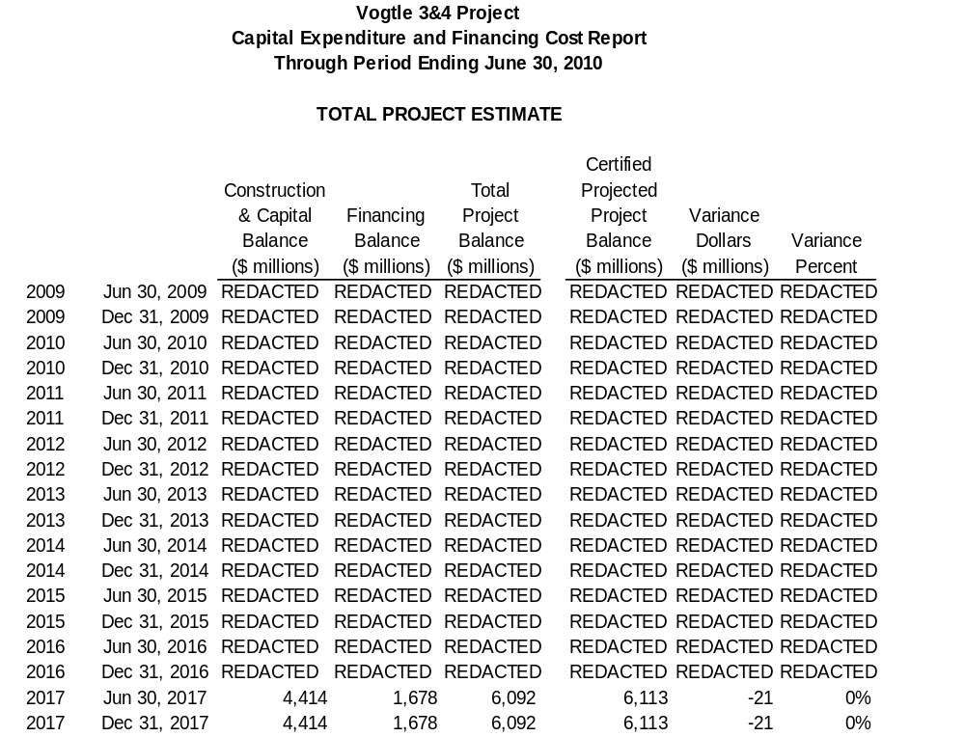
- A description of all major sources of changes (both increases and decreases) to the in-service cost and sources of change in commercial operation dates, if any.

The current Total Construction and Capital Cost for the Units is $4.414 billion and the current Total Financing Cost is $1.678 billion, for a current Total Project Cost that is now projected to be $6.092 billion, which is $21 million below the certified amount of $6.113 billion.

Table 1.1 reflects all significant sources of changes in the in-service cost. The major sources of projected cost decreases result from the Commission’s adoption of Amendment No. 3 to the EPC Agreement, as well as effective management of activities at the Project site. While both have contributed to a current cost savings, such savings are expected to be partially offset by potential new and emerging issues as previously described in the Second VCM Report, and further updated in Table 9.1 below.

Table 9.1
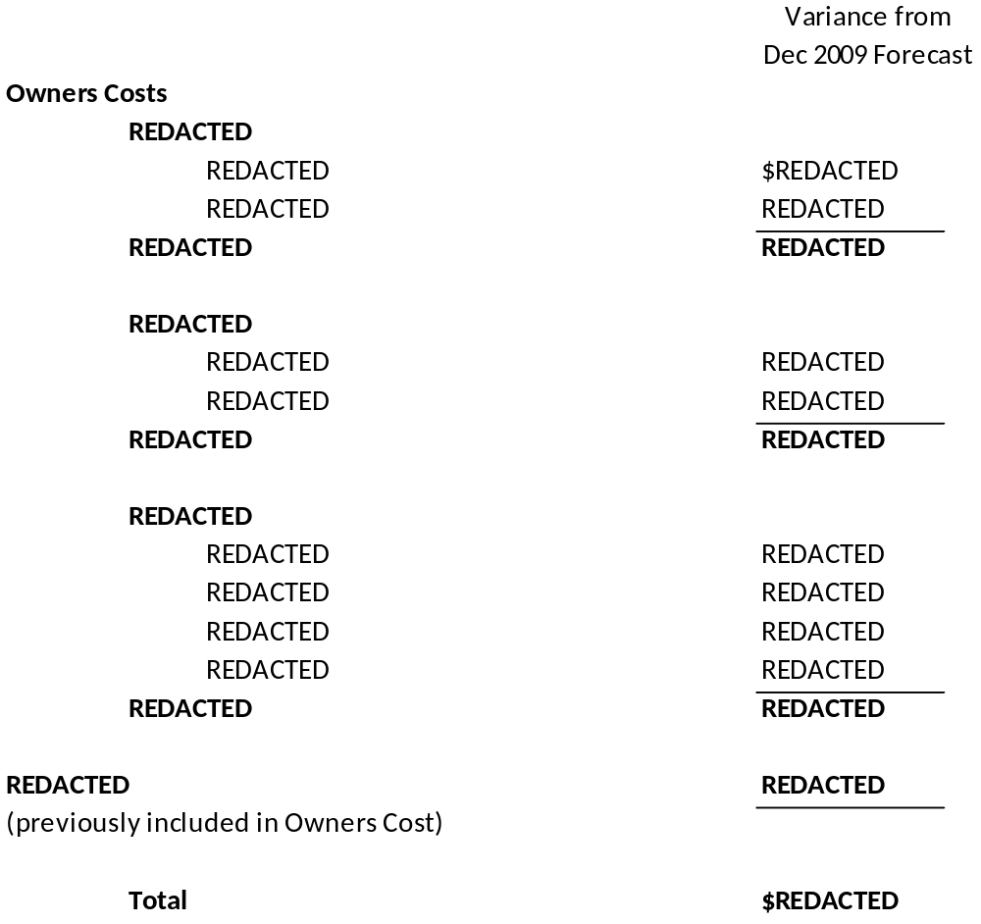
The cost estimates provided in Table 9.1 are based upon the best information available at this time. The Company will continue to closely monitor these issues and revise estimates as necessary in future reporting periods. Below is a more detailed description of the major sources of change during the Reporting Period.

REDACTED

REDACTED REDACTED. REDACTED REDACTED REDACTED REDACTED
REDACTED REDACTED REDACTED REDACTED REDACTED REDACTED
REDACTED REDACTED REDACTED REDACTED REDACTED REDACTED
REDACTED REDACTED REDACTED REDACTED REDACTED REDACTED
REDACTED REDACTED REDACTED REDACTED REDACTED REDACTED
REDACTED REDACTED REDACTED REDACTED REDACTED REDACTED
REDACTED REDACTED REDACTED REDACTED REDACTED REDACTED
REDACTED REDACTED REDACTED REDACTED REDACTED REDACTED.

REDACTED REDACTED. REDACTED REDACTED REDACTED REDACTED
REDACTED REDACTED REDACTED REDACTED REDACTED REDACTED
REDACTED REDACTED REDACTED REDACTED REDACTED REDACTED
REDACTED REDACTED REDACTED REDACTED REDACTED REDACTED
REDACTED REDACTED REDACTED REDACTED REDACTED REDACTED
REDACTED REDACTED REDACTED REDACTED REDACTED REDACTED.

REDACTED

REDACTED. REDACTED REDACTED REDACTED REDACTED REDACTED REDACTED REDACTED REDACTED REDACTED REDACTED REDACTED
REDACTED REDACTED REDACTED REDACTED REDACTED REDACTED
REDACTED REDACTED REDACTED REDACTED REDACTED REDACTED
REDACTED REDACTED REDACTED REDACTED REDACTED REDACTED
REDACTED REDACTED REDACTED REDACTED REDACTED REDACTED.

REDACTED REDACTED REDACTED REDACTED REDACTED REDACTED
REDACTED REDACTED REDACTED REDACTED REDACTED REDACTED
REDACTED REDACTED REDACTED REDACTED REDACTED REDACTED
REDACTED REDACTED REDACTED REDACTED REDACTED REDACTED
REDACTED REDACTED REDACTED REDACTED REDACTED REDACTED
REDACTED REDACTED REDACTED REDACTED REDACTED REDACTED
REDACTED REDACTED REDACTED REDACTED REDACTED REDACTED
REDACTED REDACTED REDACTED REDACTED REDACTED REDACTED
REDACTED REDACTED REDACTED REDACTED REDACTED REDACTED
REDACTED REDACTED REDACTED REDACTED REDACTED REDACTED
REDACTED REDACTED REDACTED REDACTED REDACTED REDACTED
REDACTED REDACTED REDACTED REDACTED REDACTED REDACTED
REDACTED REDACTED REDACTED REDACTED REDACTED REDACTED
REDACTED REDACTED REDACTED REDACTED REDACTED REDACTED
REDACTED

REDACTED REDACTED. REDACTED REDACTED REDACTED REDACTED REDACTED REDACTED REDACTED REDACTED REDACTED REDACTED REDACTED REDACTED REDACTED REDACTED REDACTED REDACTED REDACTED REDACTED REDACTED REDACTED REDACTED REDACTED REDACTED REDACTED REDACTED REDACTED REDACTED REDACTED REDACTED.

REDACTED

REDACTED REDACTED. REDACTED REDACTED REDACTED REDACTED REDACTED REDACTED REDACTED REDACTED REDACTED REDACTED REDACTED REDACTED REDACTED REDACTED REDACTED REDACTED REDACTED REDACTED REDACTED REDACTED REDACTED REDACTED REDACTED REDACTED REDACTED REDACTED REDACTED REDACTED REDACTED.

REDACTED REDACTED. REDACTED REDACTED REDACTED REDACTED REDACTED REDACTED REDACTED REDACTED REDACTED REDACTED REDACTED REDACTED REDACTED REDACTED REDACTED REDACTED REDACTED REDACTED REDACTED REDACTED REDACTED REDACTED REDACTED REDACTED REDACTED REDACTED REDACTED REDACTED REDACTED REDACTED.

REDACTED REDACTED REDACTED. REDACTED REDACTED REDACTED REDACTED REDACTED REDACTED REDACTED REDACTED REDACTED REDACTED REDACTED REDACTED REDACTED REDACTED.

REDACTED REDACTED. REDACTED REDACTED REDACTED REDACTED REDACTED REDACTED REDACTED REDACTED REDACTED REDACTED REDACTED REDACTED REDACTED REDACTED REDACTED REDACTED REDACTED.

In addition to the items listed above, the Company continues to evaluate other potential changes, such as the REDACTED REDACTED REDACTED REDACTED REDACTED REDACTED REDACTED REDACTED REDACTED REDACTED REDACTED REDACTED.

The Company continues to evaluate the EPC Agreement to determine whether additional related change orders are appropriate, and awaits supporting documentation to justify the change requests, but has not updated the budget to reflect these and does not plan to do so unless and until the change orders are determined to be more fully supported.

As the Construction Monitor has noted, the Company continues to provide forceful leadership of the Project and is actively involved and engaged in closely monitoring activities in the Consortium scope. But as the Construction Monitor also notes, the impact of this active oversight on Consortium performance has yet to be demonstrated. Company management is cautiously optimistic that the change in Consortium management will result in improved performance. However, as the Project continues to progress, it is possible that additional Company oversight may be required to assess the quality of vendor supply and construction. The Company continues to evaluate the appropriate level of staffing and oversight, and has not yet made any specific changes that require any updated cost estimates at this time.

- The status of the Company’s combined construction and operating license (COL) application at the Nuclear Regulatory Commission.

The most recent licensing schedule is shown in Table 10.1 below.

Significant progress continues to be made in the licensing of the Units. The ESP was received in August 2009. A significant accomplishment with regard to the ESP during this Reporting Period was the withdrawal of the appeal of the dismissal of the Joint Intervenors’ contention. In July 2009, the Joint Intervenors (a group composed of the Center for a Sustainable Coast, Savannah Riverkeeper, Southern Alliance for Clean Energy, Georgia Women’s Action for New Directions, and Blue Ridge Environmental Defense League) appealed the dismissal of certain ESP contentions to the NRC. In October 2009, the Joint Intervenors appealed to the D. C. Circuit. In January 2010, the NRC dismissed the appeal and in March 2010, the Joint Intervenors withdrew their appeal from the D.C. Circuit. The dismissal of the contention means all challenges are now closed on the receipt of the ESP.

In the last six months, the NRC review has continued on a number of specific topics in both the COL application and the DCD that is referenced by the COL application. The NRC has completed the COL Safety Evaluation Report with Open Items phase, and the Advisory Committee on Reactor Safeguards (“ACRS”) is currently meeting on the second round of NRC review material in order to issue an Advanced Safety Evaluation Report. These ACRS reviews will continue for the duration of 2010 and possibly 2011. The most significant issues are instrumentation and controls (I&C); design acceptance criteria (DAC) closure process, and Generic Safety Issue GSI-191 (long-term core cooling and downstream effects). Additionally, a special topic of interest for the ACRS relates to a public concern on containment coatings and the ability to detect localized corrosion effects in areas with limited accessibility throughout the operating life of the plant. The ACRS is seeking information from both Westinghouse and the industry to gain confidence that the public issue is satisfactorily addressed through the design and operational program. SNC and Westinghouse believe the AP1000 design adequately addresses this issue and are working together to provide the information necessary for the ACRS to resolve the matter.

The critical path review of the COL is dependent on the review of the DCD, Westinghouse’s responses to Requests for Additional Information (“RAI”) and open items from the NRC, as well as the environmental review. In a letter dated August 3, 2010, the NRC notified the Company that the draft environmental impact statement is scheduled to be issued on September 10, 2010, and the final environmental impact statement is scheduled to be issued on April 1, 2011, which supports the Project schedule.

The COL application also has a few open issues that are actively being resolved with the NRC. These are in the areas of chemical hazards, conforming seismic analysis changes due to shield building changes, and Loss of Large Areas on site associated with a specific emergency event.

There are two additional major accomplishments with regards to the COL during the Reporting Period. One was NRC acknowledgement of the Company’s cyber security plan. The second was the ASLB’s dismissal by summary disposition of the Joint Intervenors contention on Low Level Radwaste. This dismissal of the contention means that the COL proceeding was uncontested as of June 30, 2010.

SNC continued to work with Westinghouse and the NRC during the Reporting Period to support resolution of issues with the DCD and to improve overall relations between Westinghouse and the NRC. As a result, relations have improved, and on June 21, 2010, the NRC reaffirmed its schedule to support Design Certification Final Rulemaking in September 2011. Issues that have been successfully resolved for the DCD during the Reporting Period include control room ventilation issues, closure of a few select instrumentation and control design acceptance criteria, and battery testing issues. The key remaining DCD issues continue to be the design of the shield building, GSI-191, and design changes emerging from design finalization. Other DCD issues that still remain open are spent fuel pool drop height, gas accumulation, and piping design acceptance criteria. Although it is outside the reporting period, the Company notes that the paths to resolution for the DCD open issues have been reached with the NRC in each of these areas. The Company is closely monitoring the progress of these and any new items that may emerge and is interacting closely with the NRC to continue to evaluate any potential impacts on schedule.

Table 10.1
THROUGH JUNE 30, 2010
Licensing - Vogtle 3 & 4 COLA Schedule

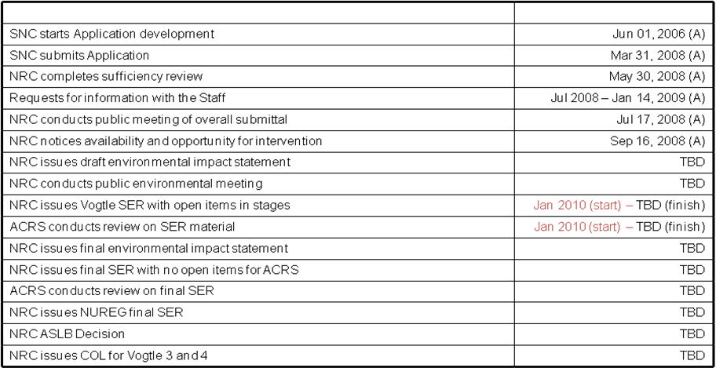
Note 1: Future NRC activity dates shown in blue were updated in January 2010 and communicated through NRC formal letters.
Note 2: For activities marked TBD, dates are projected to be provided by the NRC in July 2010.
(A) - Actual
- The status of all other significant permits and licenses required from other governmental agencies.

During this Reporting Period, the Company received two significant permits from the Georgia Department of Natural Resources; the Division of Environmental Protection. The Air Quality Construction Permit that allows construction of plant air emission sources was received on April 9, 2010. The Title V Operating Permit that allows operation of air emission sources was received on June 11, 2010. The latter permit covers the construction and operation of stationary air-emitting equipment used for operation of the Units. It includes standby and ancillary generators, cooling towers, and other equipment vital to the operation of the plant.

Table 11.1

Permit | Activity Covered | Permitting Agency | Jurisdiction | Estimated Application Date | Projected Received Date | Required Date | Responsibility | Notes
Early Site Permit (ESP) and Limited Work Authorization (LWA) | ESP -Site approval for nuclear plant construction; LWA - approval for limited safety-related work | NRC | Federal | Actual August 2006 | Actual August 26, 2009 | September 2011 | SNC
Combined Operating License (COL) | Safety related construction for a nuclear power facility | NRC | Federal | Actual March 31, 2008 | REDACTED | REDACTED | SNC
Limited Work Authorization (LWA-B) | Approval for nuclear island rebar and embeds and placement of NI base slab | NRC | Federal | Actual October 2, 2009 | REDACTED | REDACTED | SNC
Section 404 Permit | Disturbance of crossing wetland areas or navigable waters | USACE | Federal | Actual  November 9, 2009  Revised January 7,2010 | REDACTED | REDACTED | SNC | 1,7,8, 16
Section 10 Permit | Barge slip, new intake/discharge to Savannah River | USACE | Federal | Actual  November 9, 2009 Revised January 7,2010 | REDACTED | REDACTED | SNC | 1,7,8, 16
Section 401 Certification | Compliance with water quality standards | GDNR | State | Actual  November 9, 2009 Revised January 7,2010 | REDACTED | REDACTED | SNC | 7,8,16
State Waters Buffer Variance | Land disturbing activities within 25’ state waters buffer | GDNR | State | Actual  January 8, 2010 | Actual April 29, 2010 | July 2010 | SNC
Certificate of Registration | Transportation of Hazardous Material | USDOT | Federal | Actual May 2009 | Actual May 14, 2009 | June 2009 | SNC
Federal Depredation Permit | Adverse impacts on protected species and/or their nests. For site and rail corridor upgrade. | USFWS | Federal | If needed | TBD | TBD | SNC/GPC | 13
Scientific Collecting Permit | Collection of specimens | USFWS | Federal | If needed | TBD | TBD | SNC/GPC | 13
Salvage Permit | Donation or receipt of protected species (bodies, feathers, etc.) for exhibit or scientific study | USFWS | Federal | If needed | TBD | TBD | SNC/GPC | 13
Objects Affecting Navigable Airspace -  Construction Notice | Notice of erection of structures (>200’ high) potentially impacting air navigation | FAA | Federal | REDACTED | REDACTED | REDACTED | Shaw | 17
Stand-Alone Construction Projects Storm Water Permit | Discharge storm water from site during construction | GDNR | State | Actual October 2008 | ongoing | Various | SNC
National Historic Preservation Act | Consultation regarding potential to adversely affect historic resources | GDNR | State | Actual letter to SHPO transmitting MOU for signature December 2009 | Actual January 20, 2010 | June 2010 | SNC | 17
Air Quality Construction Permit | Construction air emission sources | GDNR | State | Actual March 13, 2009 | Actual June 18, 2009 | June 2009 | Shaw | 10
NPDES Wastewater Permit | Regulates limits of pollutants in liquid discharge to surface water | GDNR | State | Actual September 23, 2009 | Actual April 16, 2010 | July 2010 | SNC | 2,7,17
Air Quality Construction Permit | Construction of plant air emission sources | GDNR | State | Actual May 22, 2009 | Actual April 9, 2010 | May 2010 | SNC | 17
GA Endangered Wildlife Act | Adverse impacts on state designated protected species and/or their habitat. For site and rail corridor | GDNR | State | If needed | TBD | TBD | SNC | 13
NPDES Wastewater Permit | Regulates limits of pollutants in liquid discharge to surface water | GDNR | State | TBD | TBD | REDACTED | SNC | 14
NPDES Wastewater Permit | Regulates limits of pollutants in liquid discharge to surface water | GDNR | State | TBD | TBD | REDACTED | SNC | 14
Infrastructure Projects Construction Storm Water Permit | Discharge storm water from linear construction sites (e.g. Roadways, transmission line and rail corridor) | GDNR | State | TBD | TBD | REDACTED | GPC | 14
General Permit for Industrial Storm Water Discharges | Discharge storm water associated with industrial activity | GDNR | State | TBD | TBD | REDACTED | SNC | 4, 14
Permit to Operate a Public Water System | Operate a public, non-transient, non-community water system | GDNR | State | Actual June 16, 2009 | REDACTED | TBD | SNC | 4
Permit to Operate a Public water System | Operate a public, non-transient, non-community water system | GDNR | State | Actual September 9, 2009 | REDACTED | REDACTED | SNC | 12
Permit to Withdraw Groundwater – Make up Wells 3 and 4 | Consumptive use of 100,000 gallons per day or more of groundwater | GDNR | State | Actual May 26, 2009 | Actual July 30, 2009 | November 2009 | SNC | 4
Permit to Withdraw Groundwater – Dewatering Activities | Dewater for foundation if needed for more than 60 days | GDNR | State | Actual  September 3, 2008 | Actual March 27, 2009 | June 2009 | SNC
Certificate of Abandoned Well(s) – MU-2A | Abandoned wells have been filled, plugged and sealed (notification required 30 days after well is abandoned) | GDNR | State | REDACTED | N/A – No response required | REDACTED | SNC | 11
Certificate of Abandoned Well(s) – SW-5 | Abandoned wells have been filled, plugged and sealed (notification required 30 days after well is abandoned) | GDNR | State | Actual February 18, 2009 Notification only | N/A – No response required | NA | SNC
Permit to Withdraw Surface Water | Surface water withdrawal | GDNR | State | REDACTED | REDACTED | REDACTED | SNC
Land Disturbing Activity Permit | Permission to conduct land disturbing activities of one acre or larger, or within 25’ of any state waters | GDNR | State | N/A | N/A | N/A |  | 5
Private Industrial Landfill Permit | On-site disposal of solid waste consisting of construction and demolition debris | GDNR | State | Actual December 2008 | Actual Revised D & O Plan Received April 30, 2009 | May 2010 | SNC | 4
Solid Waste Handling Permit | Disposal of industrial solid wastes. Transportation of putrescible waste for disposal in a permitted landfill | GDNR | State | N/A | N/A | N/A | SNC | 6
Title V Operating Permit | Operation of air emission sources | GDNR | State | Actual May 22, 2009 | Actual June 11, 2010 | 2015 | SNC | 4
Certificate of Public Convenience and Necessity | Present and future public convenience and necessity requiring the operation of such equipment or facility | GA PSC | State | Actual August 1, 2008 | Actual March 17, 2009 Approved by PSC | March 17, 2009 | GPC
General Permit to Transport Radioactive Materials | Transportation of radioactive materials in the State of Georgia | GDNR/  GDPS | State | TBD | REDACTED | REDACTED | SNC | 4, 14
Utility Right-of-Way Permit | Utility right-of-way easement | GDOT | State | TBD | REDACTED | REDACTED | GPC | 14
Tennessee Radioactive Waste License-for-Delivery | Transportation of radioactive materials into the State of Tennessee | TDEC | State | TBD | REDACTED | REDACTED | SNC | 4, 14
Utah Radiation Control Rule | Transportation of radioactive materials into the State of Utah | UDEQ | State | TBD | REDACTED | REDACTED | SNC | 4, 14
Scientific Collecting Permit | State permit for collection of specimens | SCDNR | State | If needed | TBD | TBD | SNC/GPC | 13
Scientific Collecting Permit | State permit for collection of specimens | GDNR | State | If needed | TBD | TBD | SNC/GPC | 13
Land Disturbing Activity Permit | All land disturbing activities within the boundaries of Burke County | Burke County | County | N/A | N/A | N/A | N/A | 5
Building Permit | Construction, alteration, repair, or demolition of any building or structure within the boundaries of Burke County | Burke County | County | N/A | N/A | N/A | N/A | 5
Demolition Notification | Notice of demolition of buildings or structures | GDNR/  Burke County | State/  County | Various – first notification submitted in October 2008 | Various | Various | SNC
Land Disturbing Activity Permit | All land disturbing activities within the boundaries for transmission construction | Various | County | N/A | N/A | N/A | N/A | 5

Notes on Variances
1 | Permit application to be submitted in accordance with USACE regulations. Corps Master permit to cover intake and discharge
2 | If needed for Batch Plant
3 | Modification to existing permit – one for Unit 3 and one for Unit 4
4 | Modification to existing permit
5 | Not applicable since GPC is exempt pursuant to O.C.G.A 12-7-17 (10)
6 | Existing Permit – no modification required
7 | Final design info received from Shaw
8 | All items related to Corps Master permit
9 | MOU for SHPO temporarily delayed pending evaluation of Shaw inquiry on potential for relocation of intake structure
10 | Shaw Air SIP permit for construction issued June 18, 2009 by Georgia EPD; modification of permit was required due to changes in equipment needs and specifications by Shaw. Permit modification received December 29, 2009.
11 | Well MU2A will not be abandoned as originally scheduled and will be used temporarily to support construction water needs.
12 | Fire training Center (FTC) Potable Water permit application filed in September 2009 after need identified for potable water at FTC building.
13 | These permits will only be obtained if needed for the project. Permit application will be made once the need is identified and the use of TBD indicates that the permit application date will be determined consistent with the time the need is identified.
14 | TBD indicates that the State of Georgia has not indicated when these permit applications should be submitted. These permit application dates will be added as the project progresses based on input from the State of Georgia.
15 | Potable water permits issuance is based on completion of well installation and source water analysis. Working with Shaw to revise well completion schedule.
16 | These permits were resubmitted due to a Shaw calculation revision applied to the previous applications.
17 | The required date has been revised to reflect the associated construction need dates.

- The status of procurement, engineering, fabrication, transportation and erection of major equipment.

Consortium Responsibilities. There is no change to this item since the Second VCM Report. Under the EPC Agreement, the Consortium has the responsibility for all activities involving the procurement, engineering, fabrication, transportation and erection of major equipment. Georgia Power, through its agent SNC, is overseeing those activities to confirm that the Consortium is abiding by the terms of the EPC Agreement and that the Project meets the standards of quality demanded by Georgia Power.

Procurement. The June 2010 EPC Monthly Status Report and June 2010 Vogtle 3 and 4 Project Metrics Package provide more detailed information regarding the status of procurement. In summary, according to the EPC Monthly Status Report, Westinghouse and Shaw have issued 177 purchase orders (“POs”). In addition to the information presented by the Consortium, the Company also tracks planned versus actual procurement activities for major components through its Vendor Surveillance Organization. As of June 30, 2010, 60 of the 64 planned POs have been issued for the Project; the four not issued are due to misalignment between the manufacturing schedules and the current schedule. The Company’s expectation is that the Consortium will provide a schedule in the September timeframe that reflects the procurement dates that support the construction need dates, which in turn support the CODs.

The following major POs were issued during this Reporting Period:

REDACTED REDACTED REDACTED REDACTED
REDACTED REDACTED REDACTED REDACTED
REDACTED REDACTED REDACTED REDACTED

Engineering. The June 2010 EPC Monthly Status Report and June 2010 Vogtle 3 and 4 Project Metrics Package provide more detailed information regarding the status of engineering. While engineering activities are lagging and several challenges exist, the Consortium reported in the July 2010 EPC meeting that there are currently 186 deliverables to construction, and once the revised baseline is adjusted for First Nuclear Concrete, (which would then be set to REDACTED REDACTED, but is currently REDACTED REDACTED) 91 percent of the deliverables will be issued at least 12 months prior to the construction need date. The remaining 9 percent will be issued prior to the construction need date. Engineering activities are being monitored closely to ensure required actions are being taken to avoid negative impact on Project specific deliverables.

In addition to the items listed in the June 2010 EPC Monthly Status Report under Standard Plant Engineering, there are other specific challenges in a few key areas of the design that are being addressed by the Consortium with support from SNC and other industry participants. These challenges include: Reactor Coolant Pump (“RCP”) bearing redesign and RCP weld examination. With regard to the RCP bearing design, the second diagnostic test was completed satisfactorily and the inspection of the disassembled thrust bearings indicated significant improvement. REDACTED REDACTED REDACTED REDACTED REDACTED. A code case will be presented to the full ASME Code Case Committee in August.

Fabrication. The June 2010 EPC Monthly Status Report and June 2010 Vogtle 3 and 4 Project Metrics Package provide more detailed information regarding the status of fabrication. In summary, of the 26 planned fabrication starts to date, 13 have actually started. The remainder will be rescheduled with later start dates due to misalignment between the manufacturing schedules and the current schedule. The Company’s expectation is that the Consortium will provide a schedule in the September timeframe that more accurately reflects the fabrication dates that support the construction need dates, which in turn support the CODs.

The following major component fabrication started during this Reporting Period:

REDACTED REDACTED REDACTED REDACTED
REDACTED REDACTED REDACTED REDACTED
REDACTED REDACTED REDACTED REDACTED
REDACTED REDACTED REDACTED REDACTED

Construction of the SMS facility in Lake Charles, LA is complete and fabrication of CA20 began on May 3, 2010. On June 15, 2010, SMS issued a stop work order (“SWO”) at the SMS facility due to inadequate procedures and failure to comply with existing procedures. The SWO was lifted on June 21, 2010. Subsequently, Shaw, with support from SNC and SCE&G, performed a quality assurance surveillance of the SMS facility and issued another SWO on July 23, 2010. This SWO stated that the corrective action process associated with the previous SWO was deficient because it was lifted without adequate causal analysis of the corrective action report. The Company’s Vendor Surveillance and Quality Assurance Organizations continue to work with Shaw and SMS to resolve deficiencies and ensure corrective actions to prevent recurrence are implemented. The SWO was lifted August 6, 2010.

In addition to the SMS SWO, Westinghouse issued a manufacturing hold on Mangiarotti Nucleare S.p.A and Mangiarotti S.p.A stating that implementation of their quality assurance programs do not fully comply with nuclear industry standards and regulatory requirements imposed by Westinghouse. Work performed by subcontractors of Mangiarotti Nucleare S.p.A (other than Mangiarotti S.p.A) are not subject to the manufacturing hold at this time, and may continue in accordance with their current quality assurance program procedures. Westinghouse issued an additional SWO to Valinox, a subcontractor of Mangiarotti Nucleare S.p.A, because it was released to manufacture tubing without an approved quality plan.

Transportation. There is no change to this item since the Second VCM Report.

Erection of Major Equipment. The Level 1 Schedule, the June EPC Monthly Status Report and June 2010 Vogtle 3 and 4 Project Metrics Package provide detailed information regarding the status of erection of major equipment and current site activities.

The following activities are important to note:

- Backfill operation began on March 8, 2010 and, as of July 2, 2010, Unit 3 average elevation was at 155 feet and Unit 4 average elevation is 149 feet.
- Batch plant # 1 erection is complete.
- Module assembly building concrete placement is complete.
- Containment Vessel pad work is underway.
- Operations Training Facility construction is underway.

Although outside the Reporting Period, it is important to note that as a result of a July 1, 2010 internal audit conducted at the Project site, Shaw discovered that the protocol for conducting workers’ background checks was not being followed completely, as required by 10 C.F.R. 26. SNC informed the NRC of the issue and that Shaw had voluntarily suspended safety-related work at the Project site. Shaw ensured that the site was in a safe and stable condition, and then discontinued safety-related activities on July 2. SNC continues to investigate the scope and extent of the potential non-compliance, as well as whether Shaw has fully complied with the NRC’s Fitness for Duty program. SNC will continue to engage the NRC and seek NRC guidance as this process is implemented. Safety-related work resumed on August 17, 2010 after regulatory and procedural requirements were met.

- The status of transportation links for heavy forgings and modules.

As of June 30, 2010, all expected heavy forgings have been successfully transported from Japan Steel Works located in Muroran, Japan to Doosan Heavy Industries located in Changwon, South Korea. In addition to the forgings identified in the Second VCM Report, the following forgings have been transported:

- REDACTED REDACTED REDACTED REDACTED
- REDACTED REDACTED REDACTED REDACTED
- REDACTED REDACTED REDACTED
- REDACTED REDACTED REDACTED
- REDACTED REDACTED REDACTED
- REDACTED REDACTED REDACTED
- REDACTED REDACTED REDACTED REDACTED
- REDACTED REDACTED REDACTED
- REDACTED REDACTED REDACTED

- An updated comparison of the economics of the certified project to other capacity options.

The relative economic value for the Units can be determined by comparing the costs associated with completing, operating, and maintaining the Units over their useful life with the costs to build, operate, and maintain a gas-fired combined cycle (“CC”) unit, which is the next most viable generation alternative. The economic analysis performed for this Third

VCM Report relied on the methodologies used in the economic evaluations conducted in Docket Nos. 27800 and 29849.

The economic evaluation presented in this Third VCM Report is based on the same underlying major planning assumptions used in the Second VCM Report and is consistent with the Company’s 2010 Integrated Resource Plan (“IRP”) approved by the Commission on July 6, 2010 in Docket No. 31081. The 2010 IRP used a set of sixteen planning scenarios to evaluate the possible impacts of varying fuel and carbon prices. Four possible fuel price forecasts were used as well as three possible carbon price cases ($0, $10, and $20 per ton of CO₂) along with a policy case of $30/ton. Carbon prices are per ton in REDACTED REDACTED REDACTED REDACTED REDACTED REDACTED REDACTED REDACTED REDACTED.

The estimate of the capital cost to complete the Units has been updated from the Second VCM Report. Nuclear fuel cost estimates, pre-COD Operations and Maintenance (“O&M”) for the Units, post-COD O&M, spent fuel storage cost estimates, and the assumed operating characteristics of the Units have not changed. The long-term marginal financing rates for debt and preferred stock have been updated to reflect current expectations.

The economic evaluation for the period ending August 2010 compares the costs to complete, operate, and maintain the Units versus the costs to build, operate, and maintain the alternative gas-fired CC equivalent capacity over the same useful life of 60 years. “Sunk costs” (non-refundable costs already incurred or projected to have been incurred as of August 31, 2010) are excluded from this forward-looking analysis. The total currently certified construction and financing cost of $6.113 billion, net of sunk costs, is used as the basis to determine “cost to complete.” Also, for purposes of this economic evaluation, the marginal financing costs being used are higher than current estimates of embedded average financing costs. Other references to financing costs in this Third VCM Report are based on estimates of embedded average financing costs.

The relative economics for the Units, when compared to the gas-fired alternative, vary depending on the assumptions for future fuel prices as well as with the projected carbon prices associated with potential future carbon legislation. Compared to the results presented in the Second VCM Report, the benefits to customers of completing the Units have improved in all sixteen scenarios. This is primarily a result of the reduction in capital costs to complete the Units, as compared to the capital costs to complete the Units assumed in the Second VCM Report. Table 14.1 below shows the difference in lifetime costs of building, operating, and maintaining the gas-fired alternative less the lifetime costs of completing, operating, and maintaining the Units, with positive savings meaning the Units are less expensive to customers than the gas-fired CC alternative. All sixteen scenarios show positive benefits to customers for completing and operating the Units.

Table 14.1
Relative Savings of Units 3 and 4 versus CC as of August 31, 2010
Incremental Cost to Complete
(In 2016 Dollars)
(Net present value of lifetime costs of CC minus Units 3 and 4)

Fuel \ CO₂ | $0 CO₂ | $10 CO₂ | $20 CO₂ | $30 CO₂
High | REDACTED | REDACTED | REDACTED | REDACTED
Moderate w/ Volatility | REDACTED | REDACTED | REDACTED | REDACTED
Moderate | REDACTED | REDACTED | REDACTED | REDACTED
Low | REDACTED | REDACTED | REDACTED | REDACTED
Positive number means the Units are less costly than the gas-fired alternative.

Alternatively, the results of the updated economic evaluation can be expressed in terms of the “breakeven capital cost to complete.” Table 14.2 shows the results of the breakeven analysis that calculates the maximum capital expenditure that could be spent to complete the Units and maintain lifetime costs that are equal to the cost of the gas-fired alternative. In all of the scenarios, the maximum capital cost to complete the Units exceeds the Company’s current estimate of the cost to complete the Units (including marginal construction financing costs) of $REDACTED billion.

Table 14.2
Relative Savings of Units 3 and 4 versus CC as of August 31, 2010
Break-Even Cost to Complete
(In 2016 Dollars)
(Maximum Capital Costs to Complete Units 3 and 4 and Remain Economic)

Fuel \ CO₂ | $0 CO₂ | $10 CO₂ | $20 CO₂ | $30 CO₂
High | REDACTED | REDACTED | REDACTED | REDACTED
Moderate w/ Volatility | REDACTED | REDACTED | REDACTED | REDACTED
Moderate | REDACTED | REDACTED | REDACTED | REDACTED
Low | REDACTED | REDACTED | REDACTED | REDACTED
If value is higher than current estimated cost to complete of $REDACTED billion of in-service and construction financing costs, the Project benefits customers.

The analyses provided in Tables 14.1 and 14.2 are based on an economic assessment from an “incremental cost to complete” perspective, which ignores any potential cancellation fees or other costs that would be incurred if the Project were stopped as well as any fully-committed construction costs that would not be avoidable in the event the Project is cancelled. If the results from the incremental cost to complete evaluation showed it was no longer cost-effective to pursue completing the Units, a second “cancellation” assessment would have been performed to determine the economic value of canceling the Units. The “cancellation” assessment would provide the most appropriate perspective for deciding whether to cancel the Units as it would include the incremental costs to complete the Units along with the impacts of any cancellation fees or other costs associated with canceling the Project.

Tables 14.1 and 14.2 both reflect significant savings and benefits to customers from the incremental cost to complete perspective across a wide range of possible future fuel and carbon prices. Therefore, a cancellation assessment is not required at this time.

In the February 2010 Stipulation, the Company agreed to provide sensitivity studies for comparison purposes to the results provided in Table 14.2 in which total megawatt (“MW”) load is alternatively increased by 1,000 MW and decreased by 1,000 MW. These sensitivity study results are provided in Table 14.3 and Table 14.4, respectively.

Table 14.3
Relative Savings of Units 3 and 4 versus CC as of August 31, 2010
1,000 MW Load Increase Sensitivity Study
Break-Even Cost to Complete
(In 2016 Dollars)
(Maximum Capital Costs to Complete Units 3 and 4 and Remain Economic)

Fuel \ CO₂ | $0 CO₂ | $10 CO₂ | $20 CO₂ | $30 CO₂
High | REDACTED | REDACTED | REDACTED | REDACTED
Moderate w/ Volatility | REDACTED | REDACTED | REDACTED | REDACTED
Moderate | REDACTED | REDACTED | REDACTED | REDACTED
Low | REDACTED | REDACTED | REDACTED | REDACTED
If value is higher than current estimated cost to complete of $REDACTED billion of in-service and construction financing costs, the Project benefits customers.

Table 14.4

Relative Savings of Units 3 and 4 versus CC as of August 31, 2010
1,000 MW Load Decrease Sensitivity Study
Break-Even Cost to Complete
(In 2016 Dollars)
(Maximum Capital Costs to Complete Units 3 and 4 and Remain Economic)

Fuel \ CO₂ | $0 CO₂ | $10 CO₂ | $20 CO₂ | $30 CO₂
High | REDACTED | REDACTED | REDACTED | REDACTED
Moderate w/ Volatility | REDACTED | REDACTED | REDACTED | REDACTED
Moderate | REDACTED | REDACTED | REDACTED | REDACTED
Low | REDACTED | REDACTED | REDACTED | REDACTED
If value is higher than current estimated cost to complete of $REDACTED billion of in-service and construction financing costs, the Project benefits customers.

In addition to the two sensitivity studies provided in Table 14.3 and 14.4, the Company also provided a sensitivity study based on the most recently available US DOE Energy Information Administration (“EIA”) natural gas forecast. Table 14.5 contains results from a sensitivity study in which natural gas prices from the EIA Annual Energy Outlook 2010 were used. The EIA gas prices assume no carbon costs. For this study we have added carbon to the production costs to develop the $10, $20, and $30 CO₂ cases. The Company does not endorse the use of the EIA forecast sensitivity study for decision making purposes.

Table 14.5

Relative Savings of Units 3 and 4 versus CC as of August 31, 2010
EIA Gas Price Forecast Sensitivity Study
Break-Even Cost to Complete
(In 2016 Dollars)
(Maximum Capital Costs to Complete Units 3 and 4 and Remain Economic)

Fuel \ CO₂ | $0 CO₂ | $10 CO₂ | $20 CO₂ | $30 CO₂
EIA | REDACTED | REDACTED | REDACTED | REDACTED
If value is higher than current estimated cost to complete of $REDACTED billion of in-service and construction financing costs, the Project benefits customers.

- The Company will be under a continuing obligation to supplement its response to PIA Staff DR STF-TN-1-2 by ensuring that the financing data reflected in the schedules attached to that DR response reflect the most current and updated information at the time of each semi-annual monitoring report. In addition, the Company will provide the most current information shared with each of the Rating Agencies.

To comply with this requirement, the Company is including Trade Secret Exhibits 1a, 1b and 2.

- Presentations provided to the major Rating Agencies at the Company’s annual rating agency meeting held May 11-12, 2010 in Atlanta, Georgia. Attached as Exhibit 1a is the printed booklet provided to participants and Exhibit 1b is the visual aid presentation.

- An update to the schedule of Financing Issuances and Balances for the Project through 2020 under CWIP in rate base methodology, attached as Exhibit 2.

